# Planning Your Sessions

### Suggested approach for Course Planning

* Identify the topics and activities to be covered in each component or section of your course
* Identify and state the objectives of each component, i.e. what should learners be able to do, think, say by the end of the session
* Assess learners’ existing knowledge and experience
* Decide how you will check on the effectiveness of learning as the session progresses and at its end
* Choose the teaching and learning methods to be used and the resources needed
* Prepare some lesson notes in a form you can refer to later
* Work out the timings for the session
* Prepare the teaching aids and handouts you will need
* Rehearse, Rehearse, Rehearse

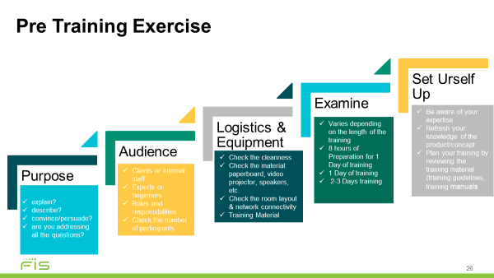

Know your purpose – Be clear about - What do you want from the audience or what does the audience need?

* What is it you seek to explain
* To describe
* To convince or persuade - Speaker is trying to persuade audience members that his/her facts are correct.
* Are you addressing all the questions – the who, what, where, when, why, how?

Audience - How much knowledge do they have? You have to pitch your presentation at the right level or if knowledge levels are variable then try to meet everyone’s need.

Logistics - time, audience size, room size/reservation (the practicalities)

Equipment - projector, screen, flip charts, and any other materials/equipment/supplies/necessary resources

Set up - Arrive early! Ensure the room is ready (chairs and tables arranged, presentation materials, name tags, audiovisual equipment) – lights, temperature, etc.

# The Learning Cycle

Adults need structure in their learning. This model ensures that the trainer covers all the fundamental asp

**Application:** the learners answer questions or consider scenarios that encourage and check their ability to transfer the skill or knowledge to their individual real-life situations.

**Concept:** the learners start constructing their understanding of the concept or main idea of the session. The trainer leads the learners to the concept using stories, analogies, problems and scenarios. These also offer familiar frames of reference, benefits and **context** to the concept.

Practice: in order to solidify the learning, the learners practise the skill or knowledge on their own. This could take the form of hands-on exercises, worksheets or reflection.

**Skill:** The learners are guided through an activity that allows them to try out the new skill or knowledge. This should be an active engagement between learner, concept and skill.